ROLE MODELS
A role model is a person whose behaviour, example, or success is or can be emulated by others, especially by young people.
Who are your role models and why?

Are you a good role model?
Positive Behaviours: | Negative Behaviours:

How do we make positive changes in order to affect the lives of others?

DREAM BOARD
- Find pictures & images that represent all your goals

- Arrange them onto your dream board

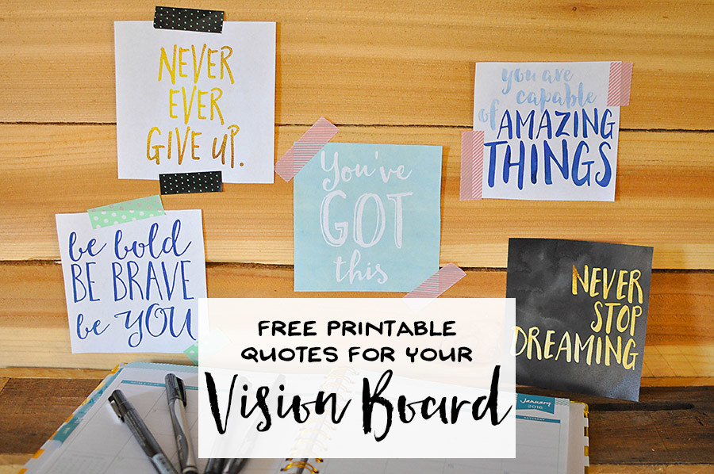
- Place your dream board somewhere you will see it EVERYDAY
Name:

Compose three statements that would be on your dream board:
1)
2)
3)

PERSONAL IMPROVEMENT GRID
Start doing… | Stop doing…
Do less of… | Do more of…

